More Than an Electric Field Guide
How NAI’s Interpretive Projects Grant helped fund an experimental program
Tom Hughes
Interpreters have a bit of an unusual relationship with technology. For one, it never works when you need it to. There is also something that just feels wrong about using iPads when part of our job is to take people out of their daily screen-addicted life. It’s just like the way uranium can be used to date billion-year-old rocks on one hand, and destroy cities on the other. Technology can be used as a supplement that reveals and connects guests to nature in new and interesting ways, or as a crutchNocturnal that leads to a stale program.
In order to bridge the gap between technophiles and nature lovers, I proposed “Nocturnal Adventures” as a part of NAI’s Interpretive Projects Grant. This program used grant funds to buy an Echo Meter Touch bat detector, a Seek thermal camera, a miniature projector and an iPad for all of them to attach to. The attempt was not to make the iPad the sole focus of the program, but to help reveal the night’s secrets in a way that was familiar to the guests. As with most programs, there were a couple of unforeseen challenges.
I thought I was being smart connecting the iPad to a mini projector in the field. How great would it be for guests to see the bat detector working without having to crouch around a little screen? Turns out an iPad can only connect to one thing at a time, which means either the bat detector or projector can work, but not in unison. In hindsight, I should have noticed. Instead of calling it a day, I figured out how to connect the iPad to the projector wirelessly – success! During the night of the program, there was an unexpected surprise: We had the pleasure of seeing bats flying behind the projector screen while the Echo Meter was identifying them – super success!
The thermal camera is a great piece of equipment, if you understand its limits. For $200, you can show how birds survive the winter with their exceptional insulation; show how cold-blooded animals aren’t “cold,” but are the same temperature as their environment; and, if you get lucky, even catch bats in flight. The goal for this program was to find maternity roosts among the trees, to which I’m still unsuccessful. But that didn’t stop the camera from being a useful addition to the program.
I think the best way to use technology during a program is to use it as a supplement and not as the main focus. While using all the really neat equipment was great, during the program my guests also listened for the audible sounds of the bats, called for coyotes, captured katydids and partook in impressions of the noises they heard at night around their own homes. If this program were just looking at the bat detector and figuring out what species they were, that would be okay, but an engaged audience that can interact with the interpreter can create a much more memorable experience.

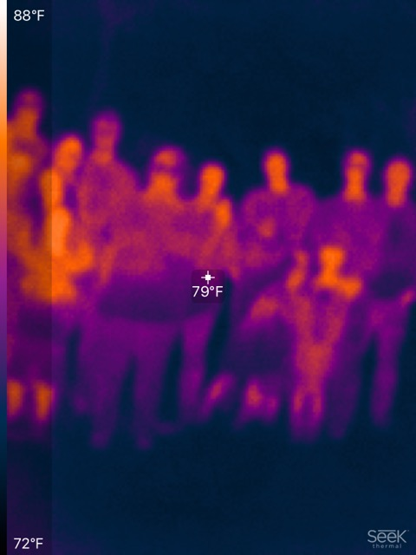
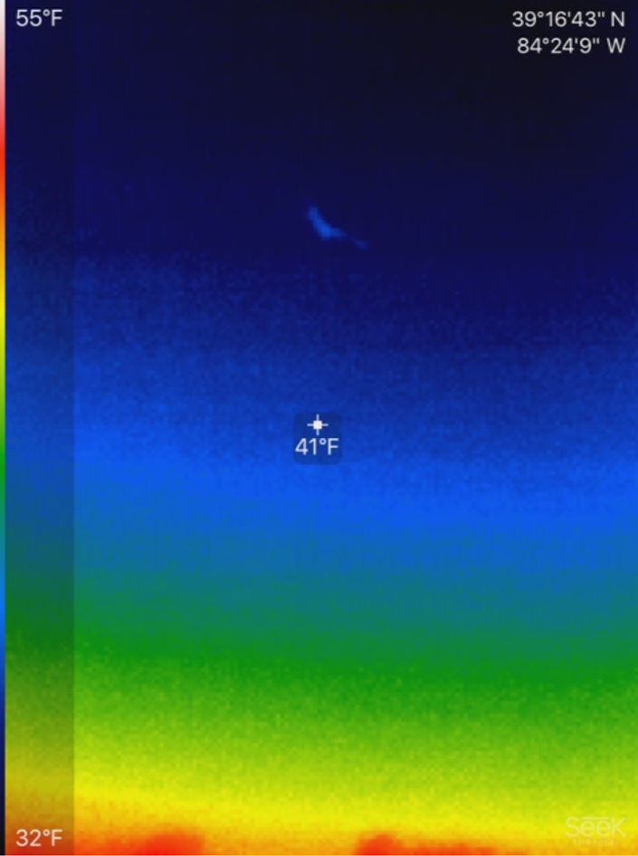
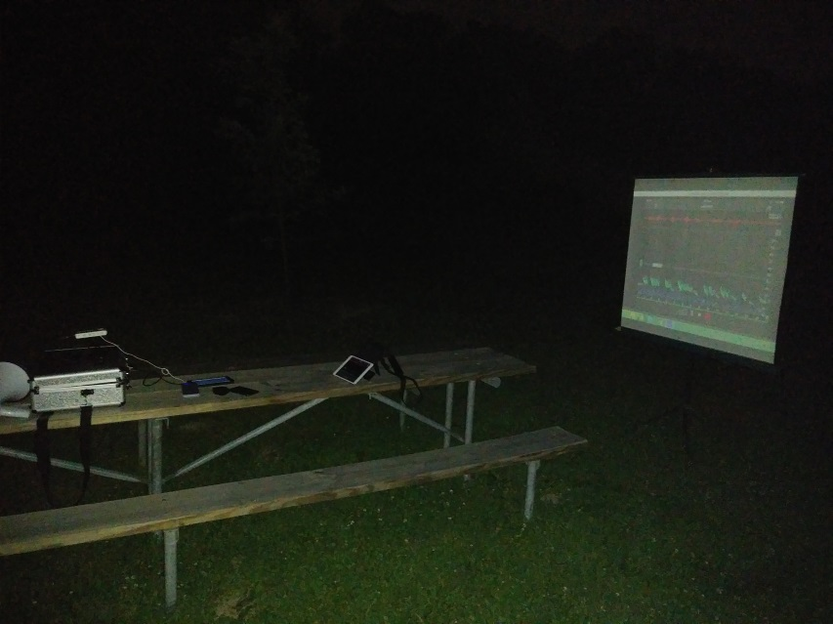
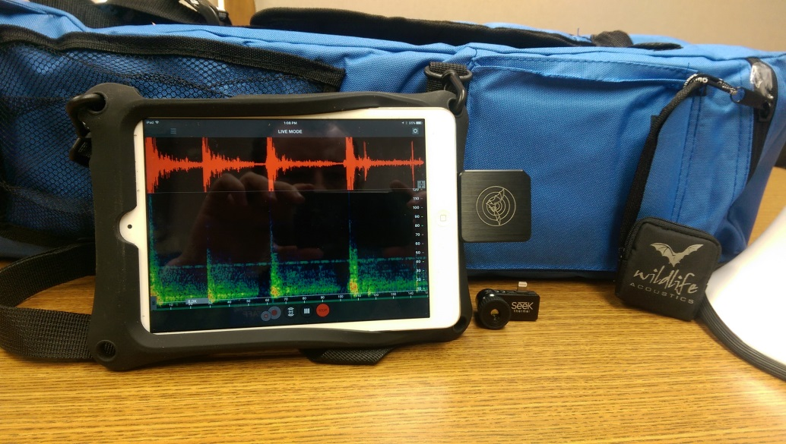
Group Thermal Picture!

Thermal Camera Bat

“A cool and unnecessarily elaborate set up”

“The Supplies”

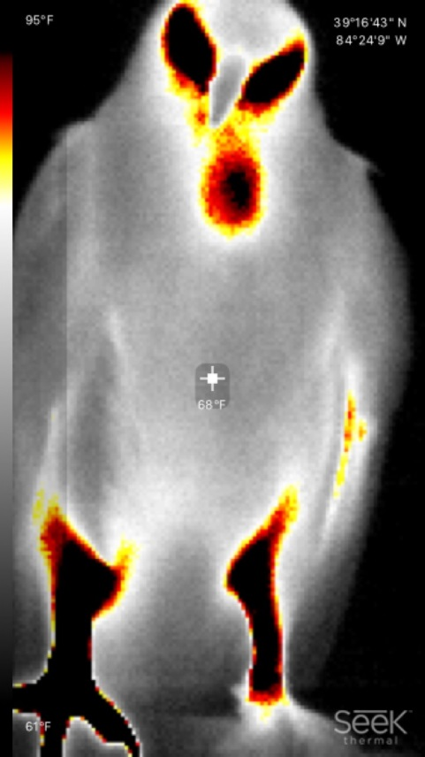
Red-Tailed Hawk Modeling for the Camera

