In 2016, Nature on the GO!, LLC was the recipient of an Interpretive Project Grant in the amount of $500. This partial funding award was allocated to be invested in the “What’s in my Watershed” program enhancement project.
Nature on the GO! travels throughout the state of Michigan providing hands-on, nature education programs to a wide variety of organizations: schools, libraries, day camps, senior living facilities, scout troops, etc… “What’s In My Watershed” is a program designed to teach people of all ages about wetland ecology and how watershed health is connected, and affected by activities that people engage in around their homes.
The funds were requested in order to offset the expenses for purchasing an Enviroscape® Point/Non-Point Source Watershed Pollution Model, an environmental educational tool that costs $879 + S&H. This plastic molded model represents a classic suburban geographic area with a farm, houses, golf course and factory all connected by roadways and waterways.
This professionally manufactured watershed model allows program participants to witness what happens when items such as fertilizers, herbicides, insecticides, motor oil, soap and other household chemicals enter the environment. The model uses food-based items to act as the offending chemicals: green Kool-Aid powder = herbicides, coffee grounds = fertilizer, coffee creamer powder = soap, etc. The “chemicals” are sprinkled on the model with an explanation that each item represents something that we use around our homes or in our yards. The lesson is then expanded upon when a spray bottle makes it “rain” on the model, causing a slurry of “chemicals” to runoff the land and into the streams and lake thus illustrating how storm water runoff carries pollutants through the watershed.
Due to its visual nature, the Enviroscape® is a highly effective interpretive tool that has greatly enhanced the “What’s in my Watershed” program. It offers an aerial view of a generic watershed yet instantly connects people to their own, local watershed and makes them more aware of the choices they make when it comes to using chemicals around the home.
Nature on the GO! Is very thankful for the NAI Great Lakes Region IPG of $500 that made the purchase of the Enviroscape® possible. At the start of every watershed program, program participants are told about NAI and that it was a grant from the Great Lakes Region of NAI that helped to make the program they are about to see possible.
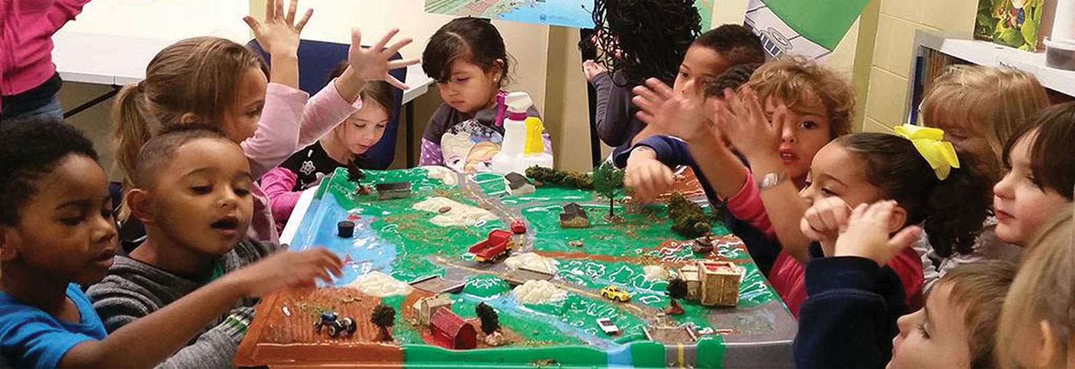
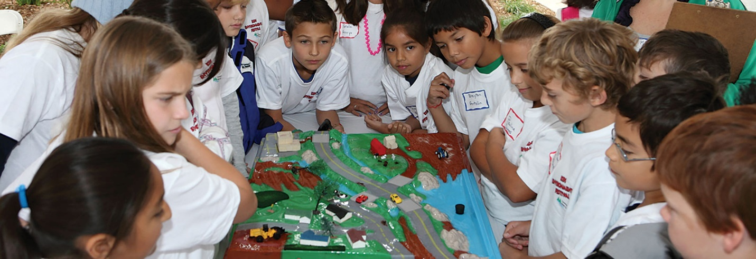
Pictures taken from the official Enviroscape® website: https://www.enviroscapes.com/

